

**CAPSTONE PROJECT 1**

**DATABASE DESIGN DOCUMENT**

**English For You**

Version 1.0

Date: Nor 11, 2018

**MENTOR** **: Mr, Truong Tien Vu**

**PROJECT TEAM** : **Fanastic 4**

**TEAM’S MEMBER** : Truc Dinh Tran Anh

Truong Do Van

Nghia Tran Nguyen Huu

Oanh Doan Nu Thuc

**INTERNATIONAL SCHOOL**

**Project Information**

|  |  |  |  |  |  |
| --- | --- | --- | --- | --- | --- |
| **Project acronym** | E4U | | | | |
| **Project Tittle** | English For You | | | | |
| **Start Date** | 15, Aug 2018 | | **End Date** | | 5 Dec 2018 |
| **Lead Institution** | International School, Duy Tan University | | | | |
| **Project Mentor & contact details** | Mr. Vu, Truong Tien  Email:  Tel: | | | | |
| **Scrum Master & contact details** | Nghia, Tran Nguyen Huu  Email:  Tel: | | | | |
| **Team members** | **Name** | **Email** | | **Tel** | |
| Truong Do Van |  | |  | |
| Truc Dinh Tran Anh |  | |  | |
| Oanh Doan Nu Thuc |  | |  | |
|  |  |  | |  | |

**Database Design Document**

|  |  |  |  |
| --- | --- | --- | --- |
| **Document Title** | Database DesignDocument |  |  |
| **Reporting Period** | Dec,5 2018 |  |  |
| **Author(s) &**  **project** | Nghia, Tran Nguyen Huu  Scrum Master | |  |
| **Team Information** | **Name** | **Role** |  |
| Truong Do Van | Member |  |
| Nghia Tran Nguyen Huu | Member |  |
| Truc Dinh Tran Anh | Member |  |
| Oanh Doan Nu Thuc | Member |  |
| **Date** | Oct 18, 2018 | **Filename** | [E4U]Database_Ver1.1.docx |
| **Access** |  | |  |

**REVISION HISTORY**

|  |  |  |  |
| --- | --- | --- | --- |
| **Version** | **Person** | **Date** | **Description** |
| V1.0 | Team | Oct 11, 2018 | Draft for Document |
| V1.1 | Do Van Truong | Oct 18, 2018 | Update |

**Document Approvals**

The following signatures are required for approval of this document.

|  |  |  |
| --- | --- | --- |
| Mr. Truong, Vu Tien  *Mentor & Product Owner* |  | Date: Oct 18, 2018 |
| Nghia, Tran Nguyen Huu  *Scrum Master* |  | Date: Oct 18, 2018 |

**1.** **Introduction:** 6

**1.1.** **Purpose:** 6

**1.2.** **Goal:** 6

**1.3.** **Scope:** 6

**1.4.** **Definitions, Acronyms and Abbreviations:** 7

**2.** **Hardware and Software Requiremant.** 7

**3.** **Database Design for Project:** 7

**3.1.** **Table Overview:** 7

**3.2.** **Entity Relationship Diagram:** 8

**3.3.** **Table Relationship Diagram:** 10

**3.4.** **Detail** 10

**3.4.1.** **User** 10

**3.4.2.** **KeyWord** 10

**3.4.3.** **Room** 11

**3.4.4.** **Catalog** 11

**3.4.5.** **Game** 11

1. **Introduction:**
   1. **Purpose:**

Place information system’s database design document describes structure of database and file structure of system. Database Design document will introduce all attribute the System that will help developer and tester base on this design to implement and test.

* 1. **Goal:**

To create database tables most accurate.

* 1. **Scope:**
* This Database Design Document provides the basic for “English For You” Database design.
* It defines the database that will support the “English For You” Data Model.
* It describes both logical and physical definition, non-functional issues, and the database interfaces; storage aspects are defined in the physical database design sections.
* The tables performance considerations requirements. The following topics are covered in this document:
* Assumptions and decisions on database design.
* Entity-mapping.
* Table column definitions.
* Primary, unique and foreign key definitions.
* Column and row level validation rules (check constraints).
* Rule for populating specific columns (sequences, derivations, demoralized (column)).
* Interfaces and dependencies with other components.
* Data access description.
* The database design for “English For You” is composed of definitions for database objects derived by mapping entities to tables attributes to columns, unique identifiers to unique keys and relationship to foreign keys.
* During design, these initial definitions are enhanced to support the functionality described in the functional specification/ user stories and defined in the primary and supporting modules of the application high level design.
  1. **Definitions, Acronyms and Abbreviations:**

|  |  |  |
| --- | --- | --- |
| **Abbreviations** | **Description** | **Comment** |
| PK/FK | Primary/ Foreign Key | Use to indicate a file is a Primary or Foreign key in a table |
| ERD | Entity Relationship Diagram | Show the relationship between entities in the system |
| AI | Auto increment | Auto increment |

1. **Hardware and Software Requiremant.**

This section provides an overview of the software and hardware architecture. The following describes the technology components of “English For You” web application.

|  |  |
| --- | --- |
| **The technology component of the TIKE** | |
| **Attribute** | **Description** |
| **Database** | Mongodb Database |
| **Software** | NodeJS, JavaScript , HTML 5, CSS |
| **Hardware** | Computer |

1. **Database Design for Project:**
   1. **Table Overview:**

|  |  |  |
| --- | --- | --- |
| **No** | **Table name** | **Short Description** |
| 1 | User | This table shows all information of Users that the system have. |
| 2 | Word | This table contains all the information detail about Words |

* 1. **Entity Relationship Diagram:**

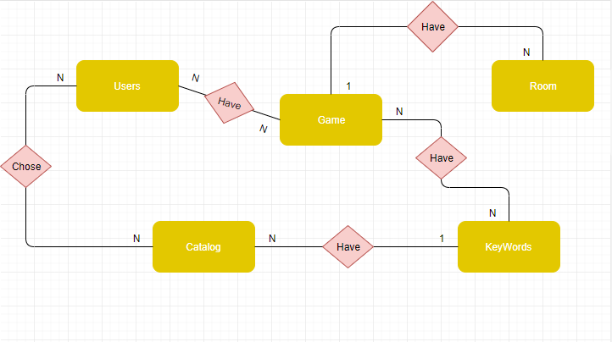

* **User (UserID: String,**

**name: String,**

**email: String,**

**CatalogID String)**

* **Word (KeyWordID: String,**

**keywords: String,**

**type: String,**

**Score: Number,**

**CatalogID: String,**

**nummberOfCharactor: Number)**

* **Catalog(CatalogID: String,**

**Name: String,**

**Descript: String)**

* **Room(RoomID: String,**

**Status: String)**

* **Game(RoomID: String,**

**UserID: String,**

**KeyWordID: String)**

* 1. **Table Relationship Diagram:**

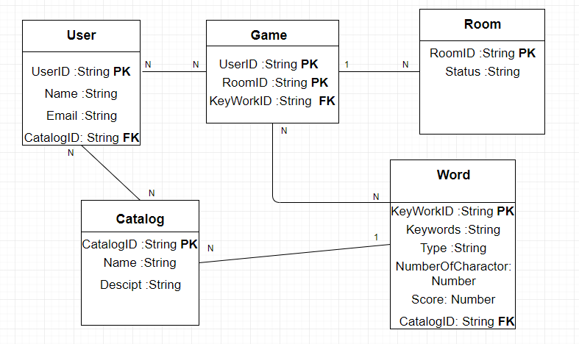

* 1. **Detail**
     1. **User**

**This includes the attribute:**

|  |  |  |  |  |  |
| --- | --- | --- | --- | --- | --- |
| **Attributes** | **Datatype** | **Null** | **Key** | **Default** | **Extra** |
| UserID | String | not | PK |  | AI |
| name | String | not |  |  |  |
| Email | String | not |  |  |  |
| CatalogID | String | not | FK |  |  |
|  |  |  |  |  |  |

* + 1. **KeyWord**

**This includes the attribute:**

|  |  |  |  |  |  |
| --- | --- | --- | --- | --- | --- |
| **Attributes** | **Datatype** | **Null** | **Key** | **Default** | **Extra** |
| KeyWordID | String | Not | PK |  | AI |
| Keywords | String | not |  |  |  |
| Type | String | not |  |  |  |
| NumberOfCharactor | Number | not |  |  |  |
| Score | Number | not |  |  |  |
| CatalogID | String | not | FK |  |  |
|  |  |  |  |  |  |
|  |  |  |  |  |  |

* + 1. **Room**

**This includes the attribute:**

|  |  |  |  |  |  |
| --- | --- | --- | --- | --- | --- |
| **Attributes** | **Datatype** | **Null** | **Key** | **Default** | **Extra** |
| RoomID | String | Not | PK |  | AI |
| Status | String | not |  |  |  |
|  |  |  |  |  |  |
|  |  |  |  |  |  |

* + 1. **Catalog**

**This includes the attribute:**

|  |  |  |  |  |  |
| --- | --- | --- | --- | --- | --- |
| **Attributes** | **Datatype** | **Null** | **Key** | **Default** | **Extra** |
| CatalogID | String | Not | PK |  | AI |
| Name | String | not |  |  |  |
| Descript | String | not |  |  |  |
|  |  |  |  |  |  |

* + 1. **Game**

**This includes the attribute:**

|  |  |  |  |  |  |
| --- | --- | --- | --- | --- | --- |
| **Attributes** | **Datatype** | **Null** | **Key** | **Default** | **Extra** |
| RoomID | String | Not | PK |  |  |
| UserID | String | not | PK |  |  |
| KeyWordID | String | not | FK |  |  |
|  |  |  |  |  |  |